New project
step
Mega Project madhe tu zaroor karaychales:
1. Data Loading & Prep
- user_data download kar (tazhye pic madhe columns)
- Missing values handle kar
- Data cleaning
2. EDA (Exploratory Data Analysis)
- Columns kahet ahet te samaj (stats, distribution)
- Correlation matrix
- Charts (histogram, scatter, box plot)
- Insights nikal
3. Feature Engineering
- New features create kar
- Scale/normalize data
- Feature selection
4. Model Training
- Multiple models try kar (Random Forest, SVM, Neural Network, etc.)
- Training data prepare kar
- Hyperparameter tuning
5. Model Testing
- Test data pramane test kar
- Cross-validation
6. Accuracy Metrics
- Accuracy, Precision, Recall, F1-Score
- ROC-AUC curve
- Confusion matrix
7. CAN Data Integration
- Python madhe CAN data read kar
- Vector CANoe/CANalyzer madhla data connect kar
8. ECU-TEST Report Reading
- ECU-TEST reports parse kar
- Results extract kar
9. API Layer (FastAPI)
- Endpoints create kar
- External API use kar (jar availabe asel) + tumchya API
10. Real-time Streaming Engine
- Data real-time stream karo
- Processing kar
11. Fault Management System
- Faults detect kar
- Alert system
12. Logging System
- Sab chikni log karo
13. Visualization Dashboard
- Charts, graphs, dashboards
14. app.py
- Sagle run karyla app.py banv
15. Mini → Mega Flow
- Mini project: EDA + Model + Accuracy (end)
- Mega project: ALS + API + Streaming + Fault + Visualization + CAN + ECU (start)
Sagle ekach .ipynb notebook madhe.
He sagle karaychales. Confusion nako, sagle step-by-step karu.
EDA
MODEL TRANING TESTION
API Create
CMD
(base) C:\Users\nutan>f:
(base) F:\>
(base) F:\>cd "F:\Project\AI_Automative_Projects\app"
(base) F:\Project\AI_Automative_Projects\app>
(base) F:\Project\AI_Automative_Projects\app>uvicorn app:app –reload
Or fast process
>cd F:/Project/AI_Automative_Projects/app && uvicorn app:app --reload --host 0.0.0.0 --port 8000
(Ha code run kraycha ani ek window open hoil firewall or chrome tyat privete seclect kraych ani access dyach)
the cmd is run so keep as it is and go the browser and past http://localhost:8000/ this and wait
http://127.0.0.1:8000
http://127.0.0.1:8000/docs

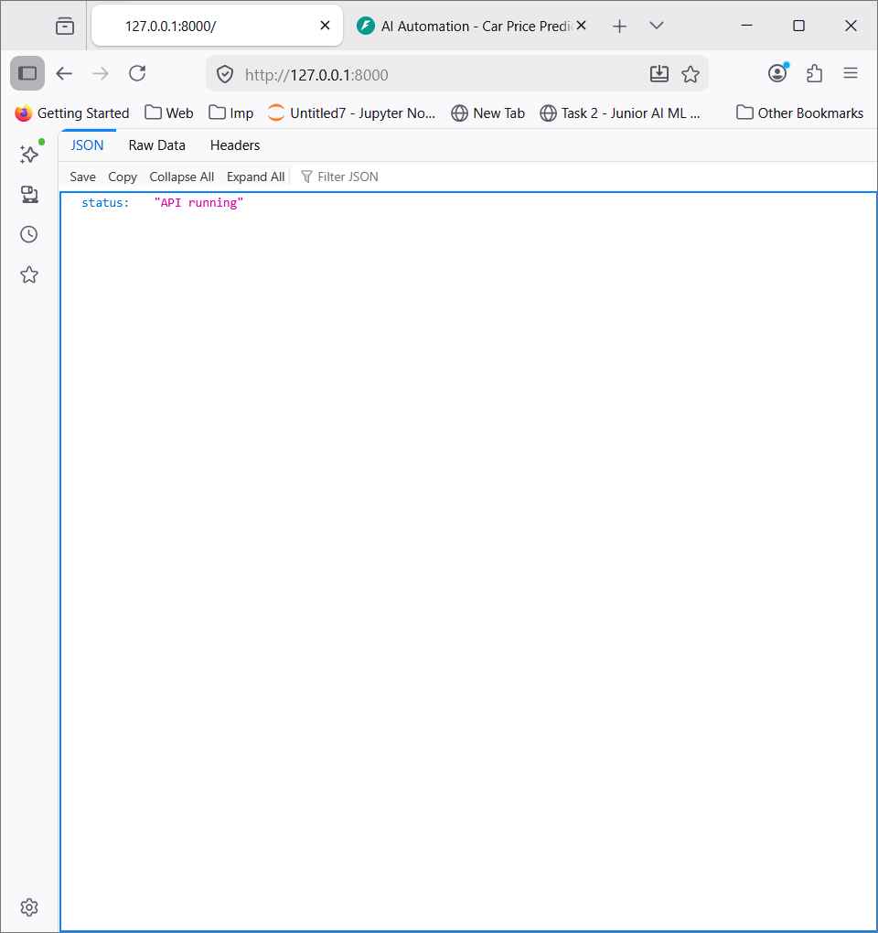 | 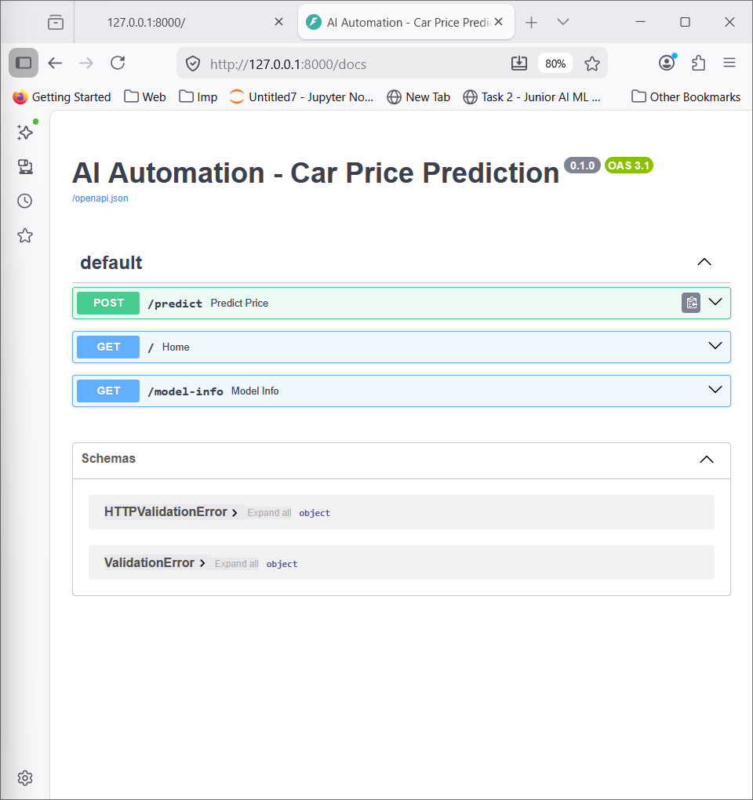

Now u crate app.py file same create the streamlit_app.py file
Part | URL | काम
FastAPI backend | http://127.0.0.1:8000/docs | API endpoints test करण्यासाठी
Streamlit UI | http://127.0.0.1:8501 | Prediction, EDA, Fault, Streaming dashboard

Then this command processing so keep as it is open new terminal and give the streamlit cmd
now check the some data


